Leonid Kozlov

How Does the Skin Electrical Resistance Vary at Different Time of the Day?

Introduction

I have always had an interest in electricity. When I was a child, I saw lightning and was curious about what it is and where it comes from. During my physics classes, I have learned a lot. It improved my ability to analyze the surroundings, moreover, it allowed me to discover, what I was neither able to see nor notice. I have learned about electricity after some time has passed; knowledge, gained during classes has inspired me to find out about even more aspects of electrical principles. In my Physics IA, I have decided to learn about human skin resistance and its characteristics. I am interested if the resistance is constant. If it is not, what affects it and how much the resistance varies?

Objective

To determine the electrical resistance of my skin at different time of the day.

Method

I am going to measure the electrical resistance of my skin on the right hand between thumb and fourth finger at different times of the day for three days on a set distance of 1 cm apart. I am going to hold the ohmmeter leads with minimal required pressure, not to let them fall. In addition, I am going to cover all resistance measuring part of the lead by my skin each time I measure my skin resistance to have less varying results. I set the ohmmeter on 2000k ohms because it measures the results more accurately this way. The days I chose to take the measurements are Monday, Tuesday, and Wednesday on the first, second, and third of February 2016. To make the leads parallel on a set distance apart, I bounded them by scotch tape.

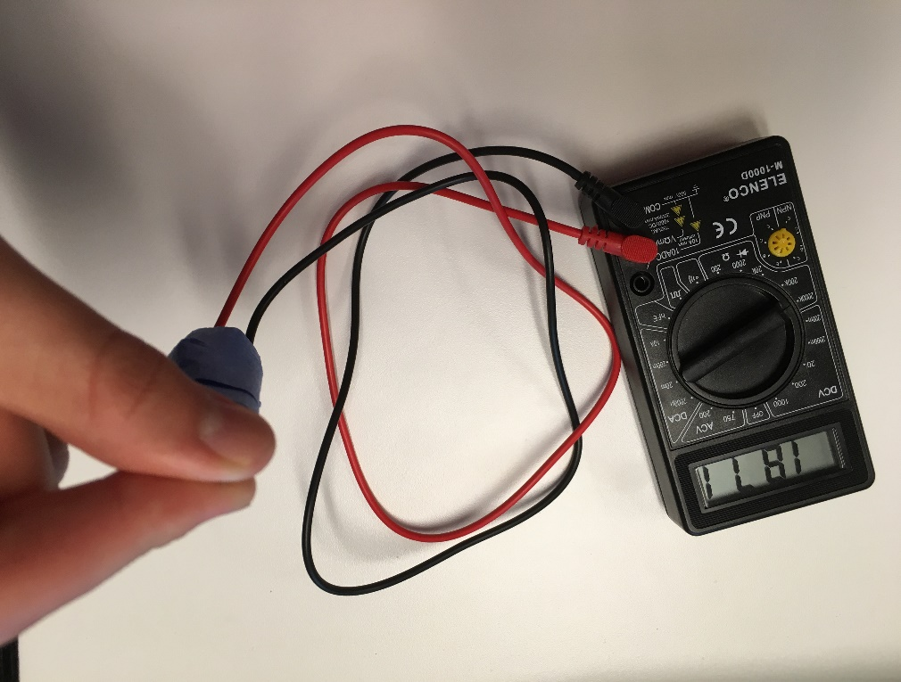

Materials

Ohmmeter, leads, scotch tape, ruler, and right hand

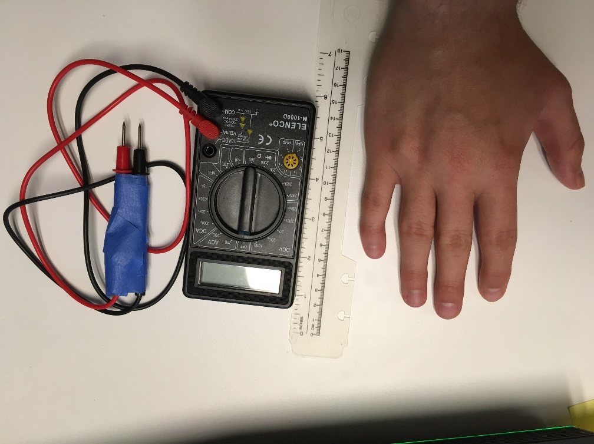

Background Information

The electrical resistance is the measure of the electric current flow decrease during the passing of electricity through the material. The unit of measure of the electrical resistance is an ohm. This concept is useful for our society because we have a lot of electrical devices in our lives. We need a supply of electricity for our daily routine and the resistance plays a very important role in it.

Electrical stations supply electricity to the cities and villages. Electrical companies try to minimize the losses of transportation of the energy. When there is less resistance in the wire, which connects the electrical station and the urban area, there are fewer losses. We laso need resistance to be able to use the same electrical network. Devices, which allow us to use the same electrical network, as other people, who live in the same city, are called resistors. We use resistors to be able to use devices, which do not need as much current, as there is in the network.

There are many types of resistors. Everything that decreases the voltage in the system is a resistor. Even wires, which are used to transfer the electricity from the electrical stations, are resistors. Our body has its own resistance. Each person has different electrical resistance, because, for example, we have different amount of fat in our body. I am interested in the electrical resistance of human skin, connected in parallel to the ohmmeter.

The electrical resistance of the skin is relative due to the fact that the human body mostly is made of water and a lot of factors affect the electrical resistance of human body. Electrical resistance of the skin does not depend only on the thickness of skin and its density. The sweat on the hands, for example, can change the resistance of the skin, so it decreases to the value, which can be many times lower than the value of dry skin. Of course, if the sweat is able to conduct electrical current more effectively than human skin, other liquids may have the same effect. This perspective allows us to realize that even the humidity of the air has significant impact on the resistance of the skin because it makes the skin wet and current has an opportunity to use quicker path to get to the cells.

Data

My Electrical Resistance of the skin.

|  |  |  |  |  |
| --- | --- | --- | --- | --- |
|  | 4 pm | 5 pm | 6 pm | 7pm |
| Monday | 1565 (ohms) | 412 (ohms) | 565 (ohms) | 1095 (ohms) |
| Tuesday | 1265 (ohms) | 841 (ohms) | 1982 (ohms) | 1058 (ohms) |
| Wednesday | 1999 (ohms) | 824 (ohms) | 1129 (ohms) | 1427 (ohms) |

Discussion

My experiments showed that the resistance of human skin varies between the time of the day and days. The highest resistance was 1999 ohms and the lowest was 412 ohms. That shows that the resistance can vary up to 4.86 times more than the initial value. The highest difference in one hour was 1175 ohms. It was a drop; however, the maximum increase in the resistance of the skin was very close. It was 1141 ohms. According to my findings, resistance can both increase and decrease with the same pace. The time of the day, when my skin resistance was higher, than any other time of the day was 4 pm. The lowest value was one hour later: at 5 pm. After, the resistance balanced between the peak and trough. The most stable time was the evening. At that time, the resistance was mostly high and the values did not change dramatically. The middle of the day was the time, when the resistance had the most severe changes. May be, the resistance depends on the emotional state of the person, because my evenings are usually distressful and daytime is full of discoveries. That may be my next experiment, whereas currently I do not have enough data to analyze that phenomenon.

Discussion of Error

There are a lot of factors, which vary from time to time, like the amount of sweat on the hands and the temperature of the body. Some factors may or may not affect the data, however, according to the results, gained; the variation of results is significant. The other source of the inaccuracy is the limitation of safety requirements. At different Amperage and Voltage, skin resistance is going to change and at certain point, electricity is going to tear the skin apart to travel through a path with less resistance. Of course, I was unable to carry out such experiments at high school, so I had to limit my study by having safe voltage, which is not going to hurt anyone. In addition, I had difficulties in finding the volunteers to help me to gather the data, because people were afraid of electrical injuries, including the fact that I conducted all the experiments under direct teacher supervision. That is the reason, why I measured only my own skin resistance at different times for three days. The ohmmeter itself was not accurate enough to measure electrical resistance without application of pressure on it, what affects the measurements.

Improvements

The ohmmeter was not very accurate, so using another one is a possible source of accuracy improvement. The data was taken for three days, so measuring the resistance for a longer period is going to improve the analysis of data. Taking measurements from more people, possibly with different age and weight can help to determine, who has higher electrical resistance, based on the age, weight, or even gender. By measuring the electrical resistance with different distances between wires, which are used to measure the resistance, I can determine the relation between distance and resistance of the skin.